# ASSIGNMENT 2

Muhammed Rameez V M

234103312

* Grid Detail

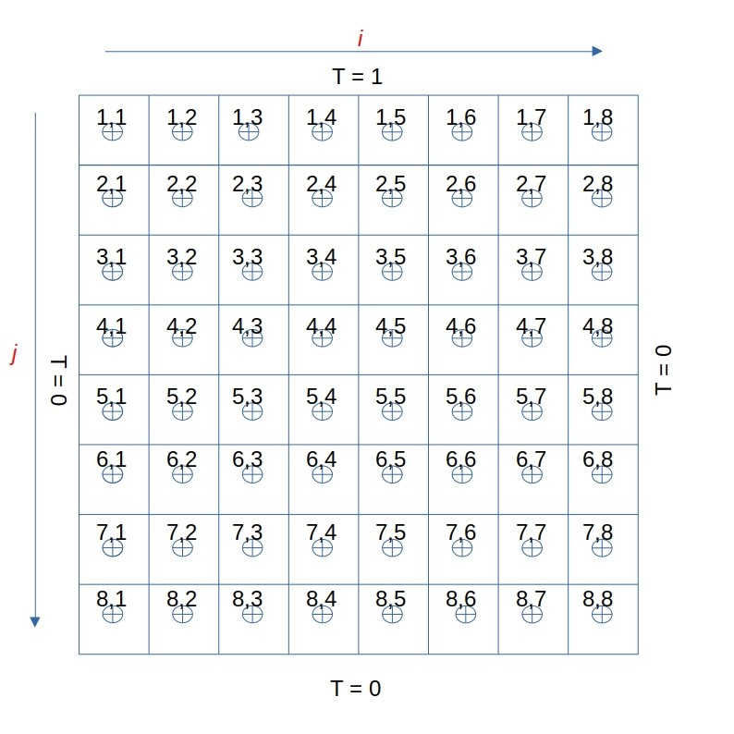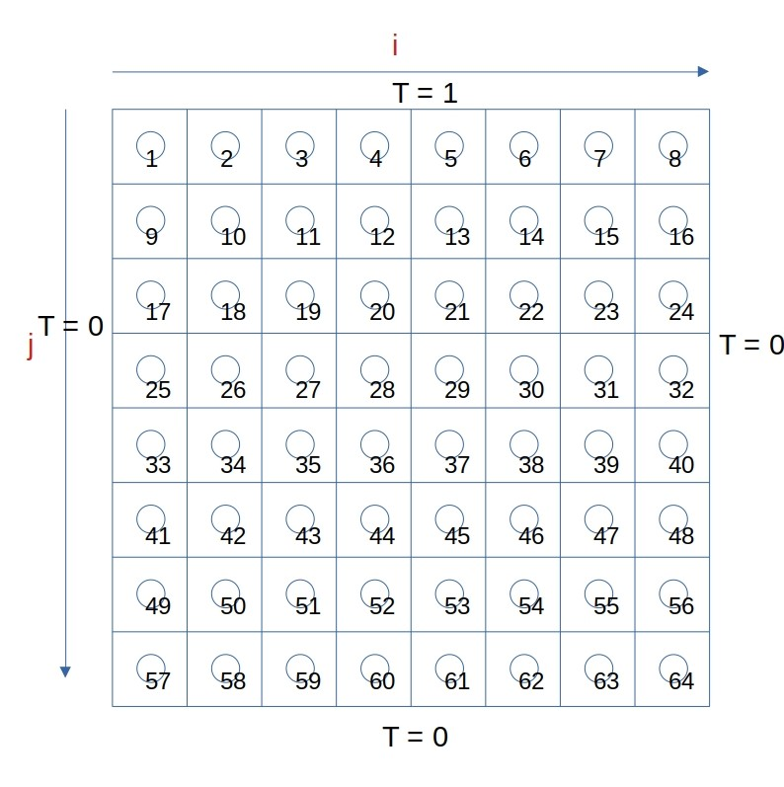

Fig.1 Normal ordering Fig.2 Lexicographic ordering

* Discretized Equation

$\iiint{\left(\frac{∂^{2}T}{∂x^{2}}+ \frac{∂^{2}T}{∂y^{2}}\right)dv=0 }$ (1)

$\iint{∇T\hat{n}} . ds=0$ (2)

${\left(\frac{∂T}{∂x}\right)}_{e}∆y.1- {\left(\frac{∂T}{∂x}\right)}_{w}∆y.1+ {\left(\frac{∂T}{∂y}\right)}_{n}∆x.1- {\left(\frac{∂T}{∂y}\right)}_{s}∆x.1=0$ (3)

$\left(\frac{T_{i+1}- T_{i}}{∆x}\right)∆y- \left(\frac{T_{i}- T_{i-1}}{∆x}\right)∆y+ \left(\frac{T_{i+ n}- T_{i}}{∆y}\right)∆x- \left(\frac{{ T_{i}- T}_{i- n}}{∆y}\right)∆x=0$ (4)

Where $1≤i≤N,$ N = ni x nj , n = ni = ni

ni and nj are the number of rows and columns of the grid respectively.

Now eq.4 becomes

${-β}^{2}T_{i-n}- T_{i-1}+2\left(1+β^{2}\right)T_{i}- T_{i+1}{-β}^{2}T_{i+n}=0$ (5)

For top layer, there is no north node. But instead there will be boundary.

So, $T_{N}+T_{i}=2T_{top}$. $T_{i-n}= T_{N}$

i.e, $T_{i-n}=$ $2T_{top}- T_{i}$

At boundary, the coefficient of $T_{i}$ terms will increase and constant values goes to RHS.

A T = Boundary values

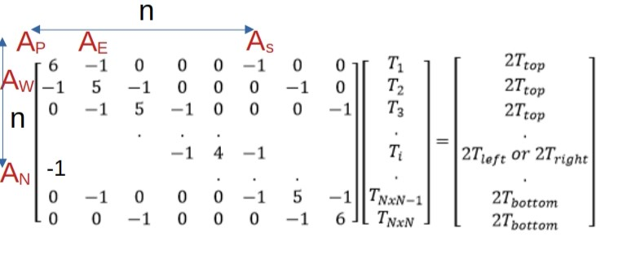

**Conjugate Gradient Method**

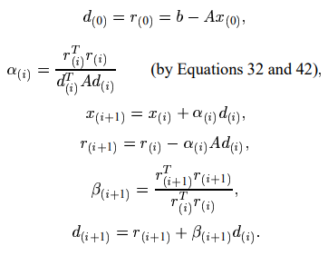

**Preconditioned Conjugate Gradient Method**

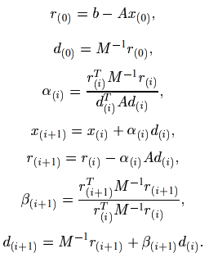

**Coding Part**

An input.txt file is made reading inputs required which include the Number of grids, temperature BCs , Upper limit , Lower limit

step size ,dx or dy = (Upper limit - Lower limit ) / No of grid points

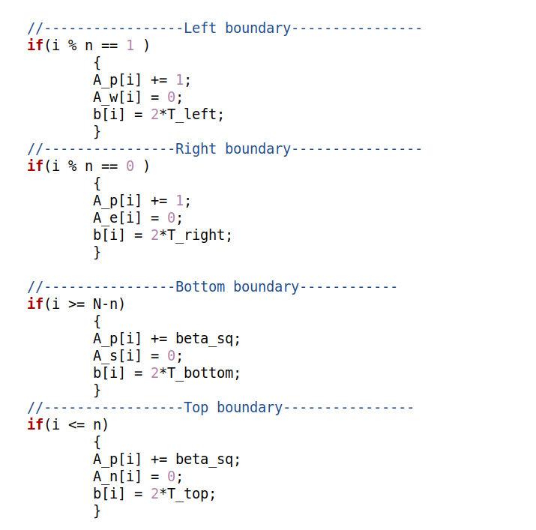

Inside conjugate gradient method

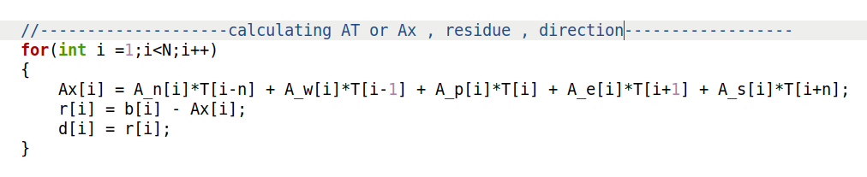 After this , we will iterate till convergence criteria is satisfied

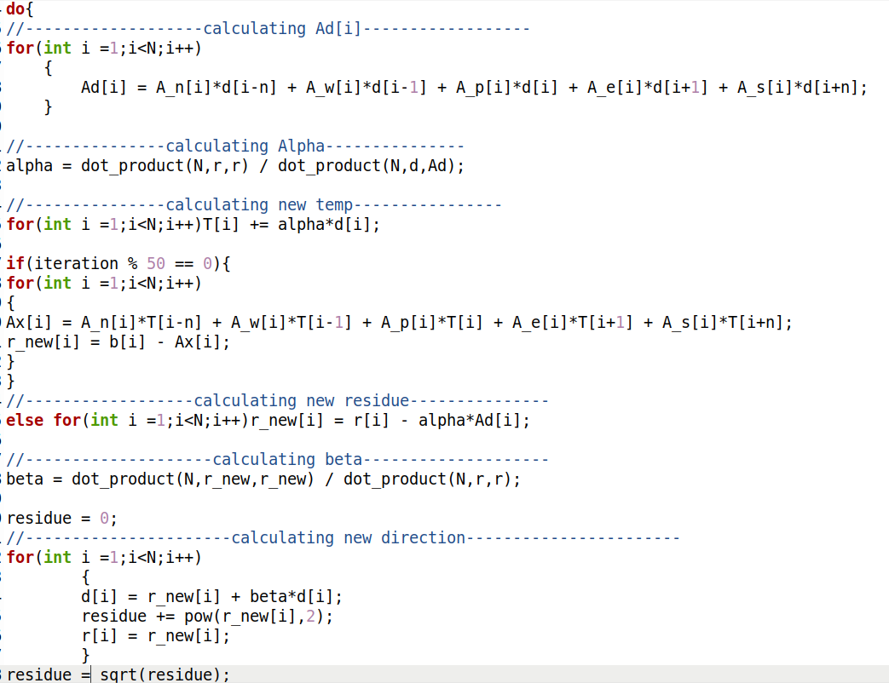

**Preconditioned Conjugate Gradient Method**

In jacobi precondtioner , the diagonal of matrix A is taken as M

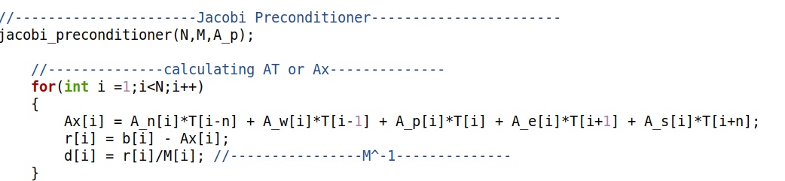

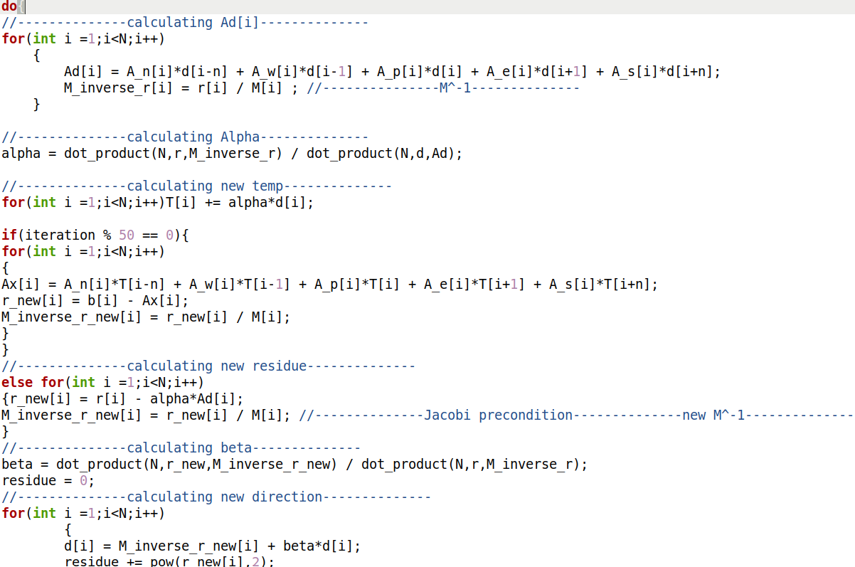

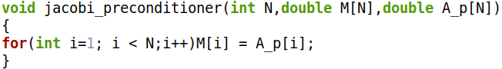

For ILU , the matrix M changes

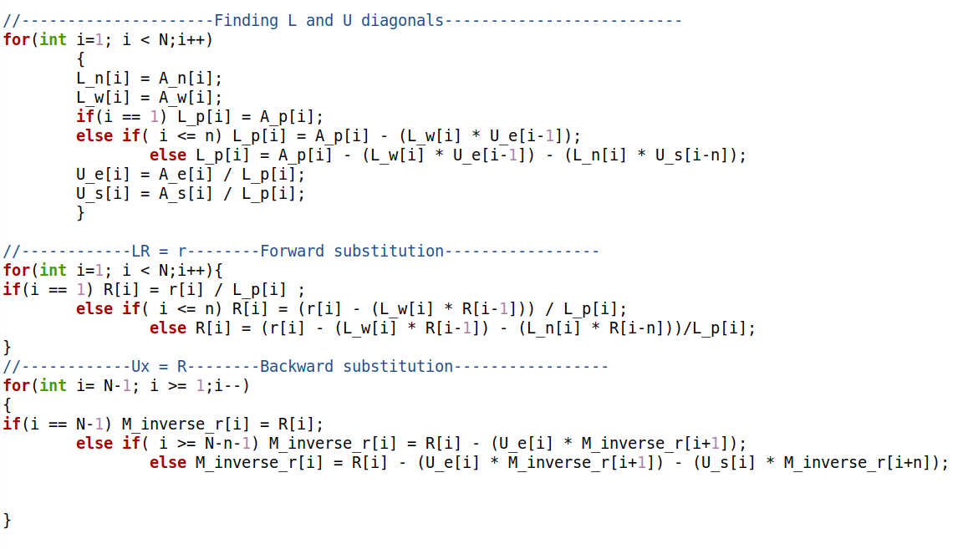

**Results**

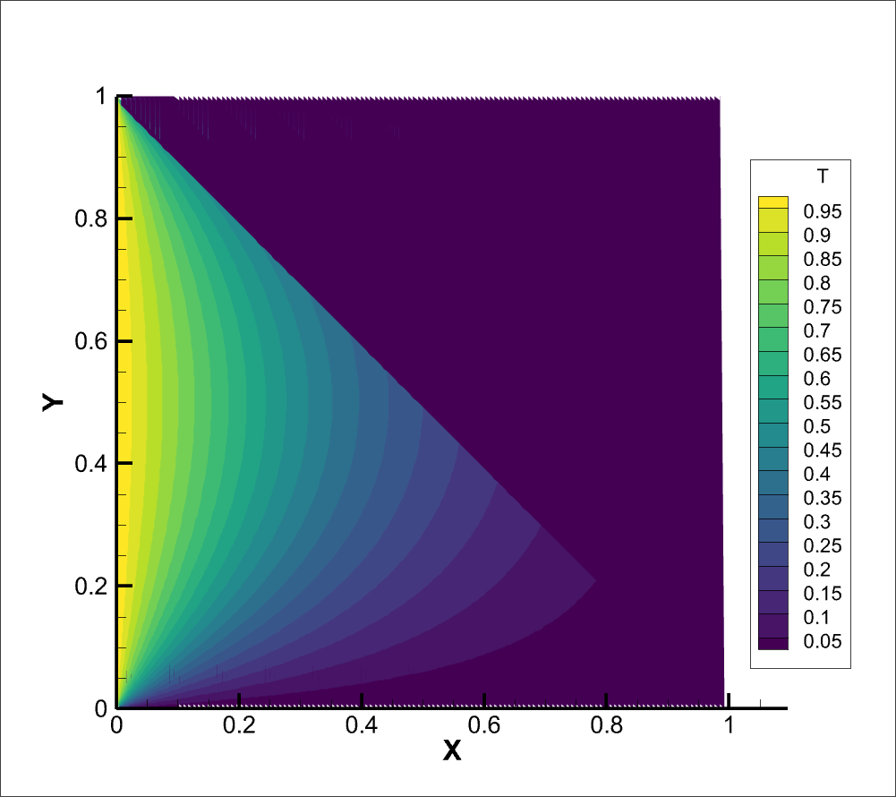

Fig.1 Contour for CG method

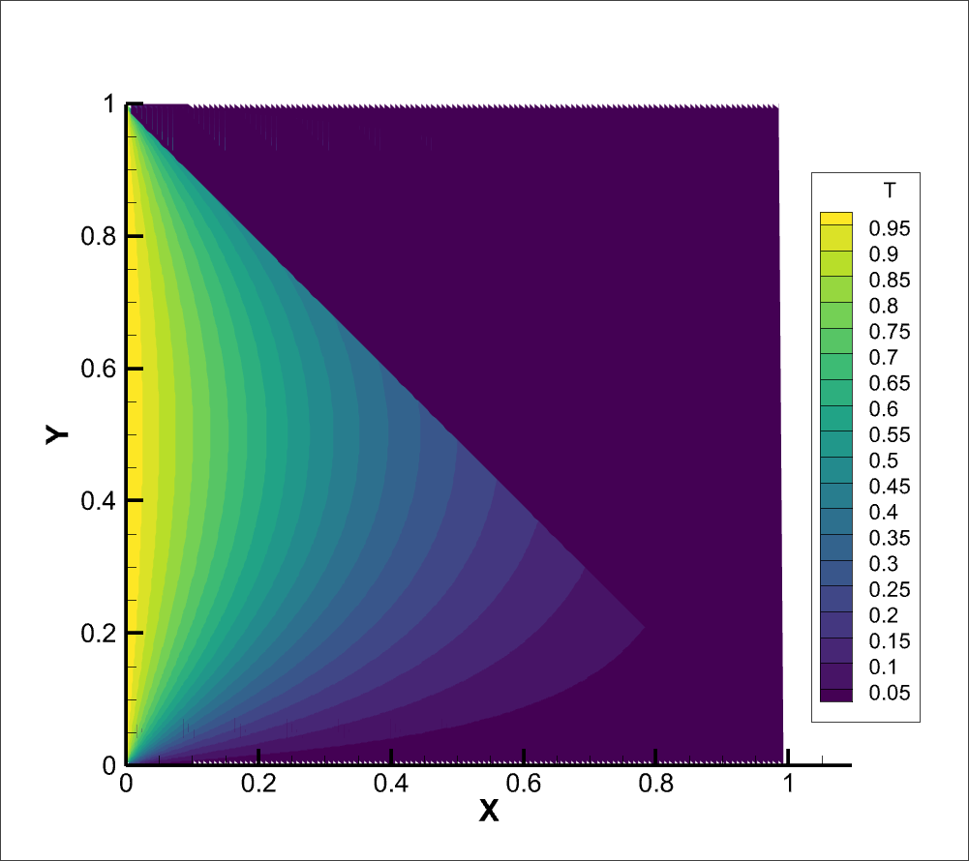

Fig.1 Contour for Jacobi Preconditioned CG method

**FMG**

|  |  |  |  |
| --- | --- | --- | --- |
| **Relaxation Method** | **Wave Number , k** | **Residual** | **Required Iterations** |
| Weighted Jacobi | 1 | 22.919425 | 8 |
| Gauss Siedel | 1 | 19.641558 | 6 |
| Weighted Jacobi | 10 | 2941.761565 | 10 |
| Gauss Siedel | 10 | 2164.555850 | 7 |